Homework 15 – Kubernetes Storage – Velibor Stanisic

Kubernetes is a free and open-source container orchestration platform. It provides services and
management capabilities needed to efficiently deploy, operate, and scale containers in a cloud or
cluster environment.

When managing containerized environments, Kubernetes storage is useful for storage
administrators, because it allows them to maintain multiple forms of persistent and non-persistent
data in a Kubernetes cluster. This makes it possible to create dynamic storage resources that can
serve different types of applications.

Practice 1: Direct provisioning of Azure File storage
1. Login to Azure and connect to your AKS cluster.
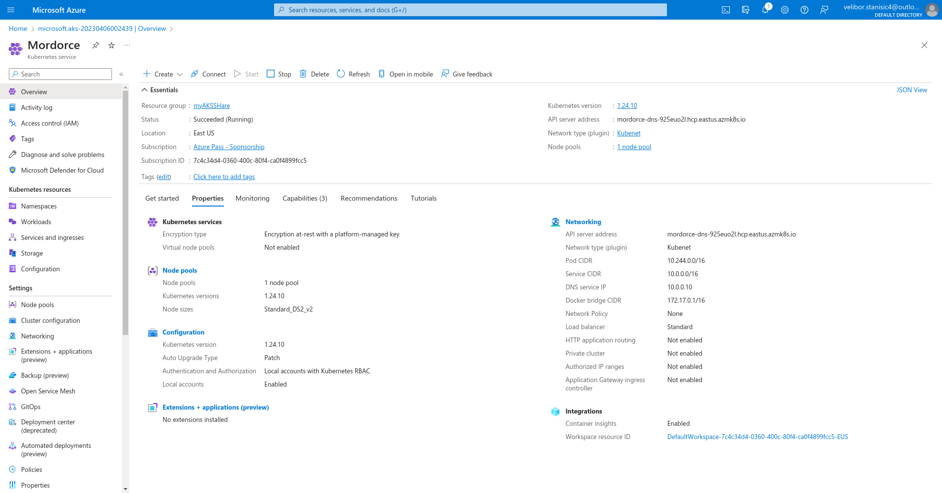

2. Check if any pods run under the default namespace if so delete everything under the default namespace.

3. In this practice we will directly provision Azure Files to a pod running inside AKS.

4. First create the Azure Files share. Run the following commands:
# Change these four parameters as needed for your own environment
AKS_PERS_STORAGE_ACCOUNT_NAME=mystorageaccount$RANDOM
AKS_PERS_RESOURCE_GROUP=myAKSShare
AKS_PERS_LOCATION=eastus
AKS_PERS_SHARE_NAME=aksshare

# Create a resource group
az group create --name $AKS_PERS_RESOURCE_GROUP --location $AKS_PERS_LOCATION
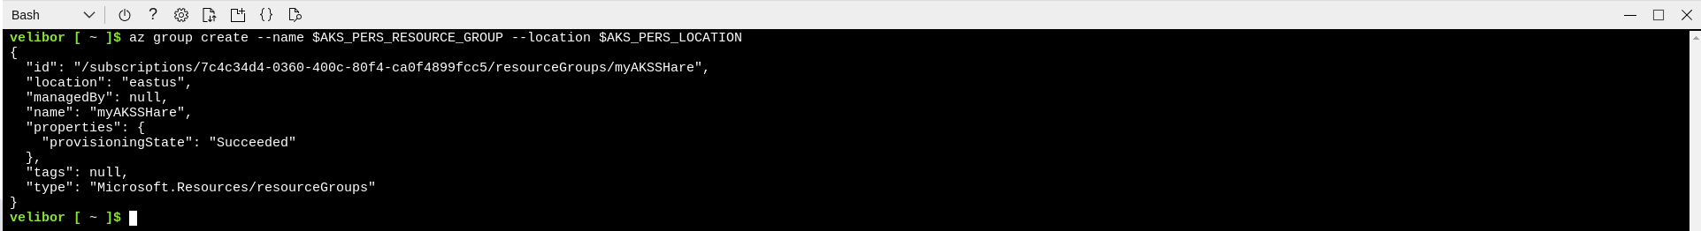

# Create a storage account
az storage account create -n $AKS_PERS_STORAGE_ACCOUNT_NAME -g $AKS_PERS_RESOURCE_GROUP -l
$AKS_PERS_LOCATION --sku Standard_LRS
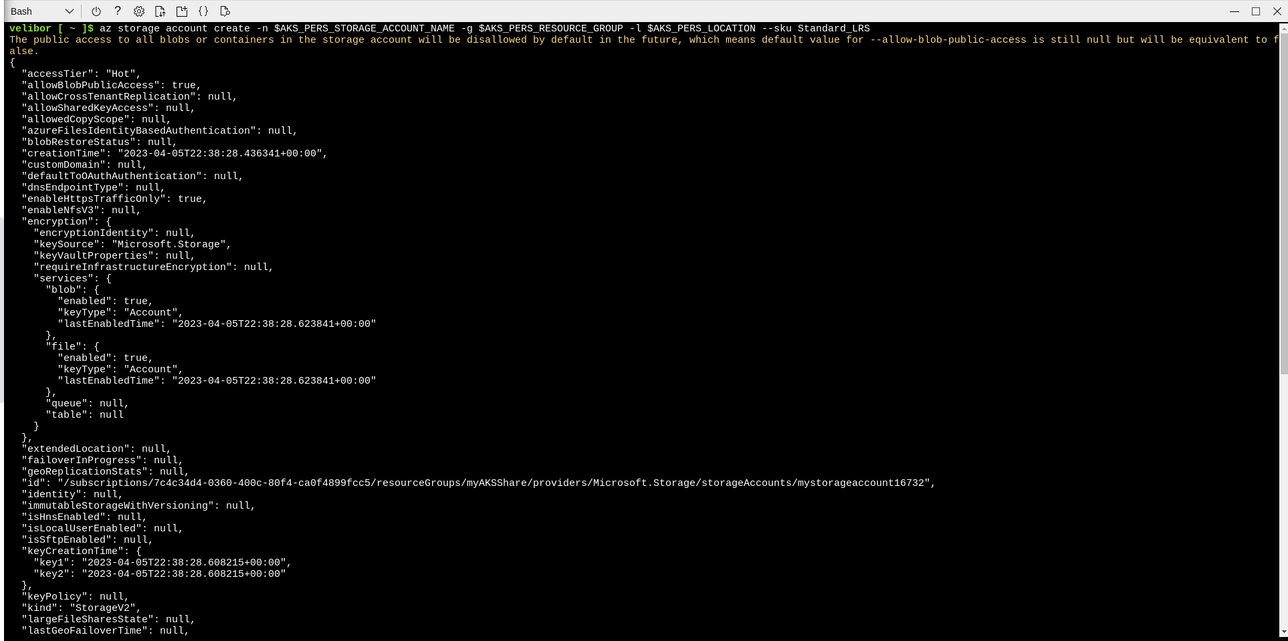

# Export the connection string as an environment variable, this is used when creating the Azure file share
export AZURE_STORAGE_CONNECTION_STRING=$(az storage account show-connection-string -n
$AKS_PERS_STORAGE_ACCOUNT_NAME -g $AKS_PERS_RESOURCE_GROUP -o tsv)

# Create the file share
az storage share create -n $AKS_PERS_SHARE_NAME --connection-string
$AZURE_STORAGE_CONNECTION_STRING

# Get storage account key
STORAGE_KEY=$(az storage account keys list --resource-group $AKS_PERS_RESOURCE_GROUP --account-name
$AKS_PERS_STORAGE_ACCOUNT_NAME --query "[0].value" -o tsv)

# Echo storage account name and key
echo Storage account name: $AKS_PERS_STORAGE_ACCOUNT_NAME
echo Storage account key: $STORAGE_KEY

5. Make a note of the storage account name and key shown at the end of the script output. These values are needed when you create the Kubernetes volume in one of the following steps.
6. Now we will need to create a Kubernetes secret that will be used to mount the Az File Share to the pod. You need to hide this information from the pod’s definition and K8S secret is the best way to do it.
7. Run the following (single) command to create the secret:
kubectl create secret generic azure-secret --from- \
literal=azurestorageaccountname=$AKS_PERS_STORAGE_ACCOUNT_NAME \
--from-literal=azurestorageaccountkey=$STORAGE_KEY
8. Check if secret was created. Run kubectl get secret -A.

9. Now we can create the pod and mount the Azure File. Create a new file named azure-files-pod.yaml with the following contents:
apiVersion: v1
kind: Pod
metadata:
name: mypod
spec:
containers:
- name: mypod
image: mcr.microsoft.com/oss/nginx/nginx:1.15.5-alpine
resources:
requests:
cpu: 100m
memory: 128Mi
limits:
cpu: 250m
memory: 256Mi
volumeMounts:
- name: azure
mountPath: /mnt/azure
volumes:
- name: azure
azureFile:
secretName: azure-secret
shareName: aksshare
readOnly: false

10. Run kubectl apply -f azure-files-pod.yaml.

11. You now have a running pod with an Azure Files share mounted at /mnt/azure.
12. You can use kubectl describe pod mypod to verify the share is mounted successfully. Search for the Volumes section of the output.
13. Now exec to the pod and try to access the mounted file share. Run the following command
kubectl exec -it mypod -- bash

14. Go to /mnt/azure and create a blank file test.txt file.

15. Go to the portal and locate your Azure storage provisioned for this practice.
16. Under the Files section, check the contents of the Azure file share and check if test.txt file exists.
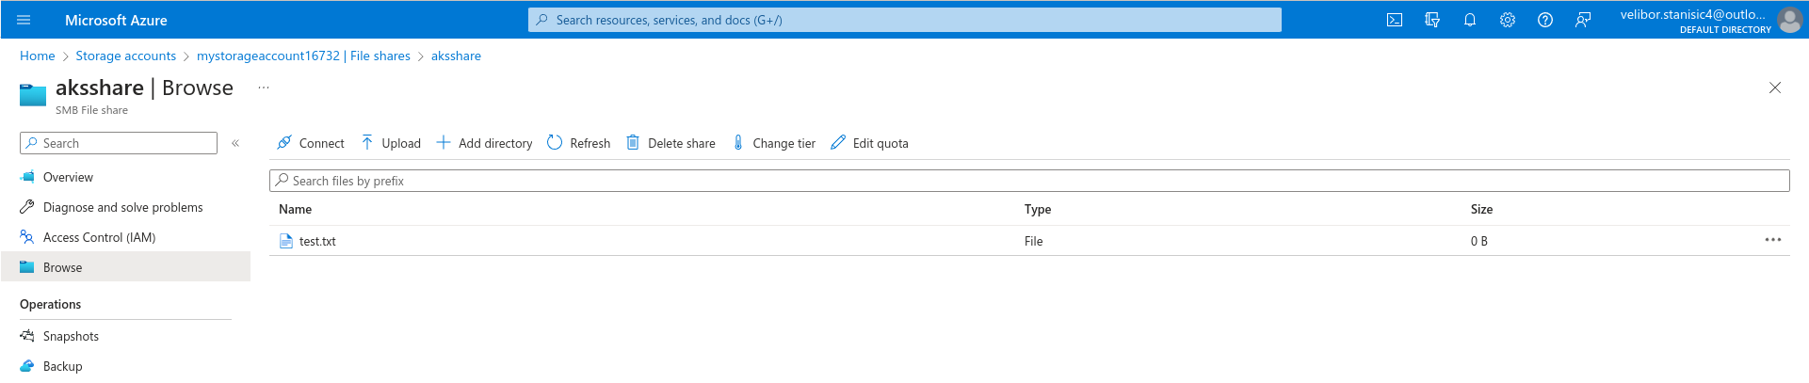

Practice 2: Provisioning Azure File storage using PVs and PVCs
1. Login to Azure and connect to your AKS cluster.
2. Check if any pods run under the default namespace if so delete everything under the default namespace.

3. Now we will provision Azure files storage to a pod using PV and PVC.

4. Create a azurefile-mount-options-pv.yaml file with a PersistentVolume like this:
apiVersion: v1
kind: PersistentVolume
metadata:
name: azurefile
spec:
capacity:
storage: 5Gi
accessModes:
- ReadWriteMany
azureFile:
secretName: azure-secret
shareName: aksshare
readOnly: false
mountOptions:
- dir_mode=0777
- file_mode=0777
- uid=1000
- gid=1000
- mfsymlinks
- nobrl

5. Note the access mode. Can you use other mode with Azure files?
Azure Files supports two access modes in Kubernetes: ReadWriteOnce and ReadWriteMany

6. Now create a azurefile-mount-options-pvc.yaml file with a PersistentVolumeClaim that uses the
PersistentVolume like this:
apiVersion: v1
kind: PersistentVolumeClaim
metadata:
name: azurefile
spec:
accessModes:
- ReadWriteMany
storageClassName: ""
resources:
requests:
storage: 5Gi

7. Execute kubectl apply -f azurefile-mount-options-pv.yaml and kubectl apply -f azurefile-mount-options-pvc.yaml.
8. Verify your PersistentVolumeClaim is created and bound to the PersistentVolume. Run kubectl get pvc azurefile.
9. Now we can embed the PVC info inside our pod definition. Create the following file azure-files-pod.yaml with following content:
apiVersion: v1
kind: Pod
metadata:
name: mypod
spec:
containers:
- name: mypod
image: mcr.microsoft.com/oss/nginx/nginx:1.15.5-alpine
resources:
requests:
cpu: 100m
memory: 128Mi
limits:
cpu: 250m
memory: 256Mi
volumeMounts:
- name: azure
mountPath: /mnt/azure
volumes:
- name: azure
persistentVolumeClaim:
claimName: azurefile

10. Run kubectl apply -f azure-files-pod.yaml.

11. You now have a running pod with an Azure Files share mounted at /mnt/azure.
12. You can use kubectl describe pod mypod to verify the share is mounted successfully. Search for the Volumes section of the output.
13. Now exec to the pod and try to access the mounted file share. Run the following command
kubectl exec -it mypod -- bash

14. Go to /mnt/azure and create a blank file test.txt file.

15. Go to the portal and locate your Azure storage provisioned for this practice.
16. Under the Files section, check the contents of the Azure file share and check if test.txt file exists.

17. Delete the mypod the pv and pvc you have created so far. What happens to the Azure File share?
The Azure Files share will continue to exist in Azure storage account even after we deleted the resources in your Kubernetes cluster.

Practice 3: Provisioning Azure file storage using Storage Classes
1. Login to Azure and connect to your AKS cluster.
2. Check if any pods run under the default namespace if so delete everything under the default namespace.

3. Now we will provision file storage using the definition of storage classes. Create a file named azure-file-sc.yaml and copy in the following example manifest:
kind: StorageClass
apiVersion: storage.k8s.io/v1
metadata:
name: my-azurefile
provisioner: kubernetes.io/azure-file
mountOptions:
- dir_mode=0777
- file_mode=0777
- uid=0
- gid=0
- mfsymlinks
- cache=strict
- actimeo=30
parameters:
skuName: Standard_LRS

4. Create the storage class with kubectl apply -f azure-file-sc.yaml .

5. Now we will create the PVC that will consume the storage class defined previously. Create a file named azure-file-pvc.yaml and copy in the following YAML:
apiVersion: v1
kind: PersistentVolumeClaim
metadata:
name: my-azurefile
spec:
accessModes:
- ReadWriteMany
storageClassName: my-azurefile
resources:
requests:
storage: 5Gi

6. Create the persistent volume claim with the kubectl apply -f azure-file-pvc.yaml.

7. Once completed, the file share will be created. A Kubernetes secret is also created that includes connection information and credentials. You can use the kubectl get pvc my-azurefile command to view the status of the PVC.
8. Now we will create the pod that consumes the PVC. Create a file named azure-pvc-files.yaml, and copy in the following YAML. Make sure that the claimName matches the PVC created in the last step:
kind: Pod
apiVersion: v1
metadata:
name: mypod
spec:
containers:
- name: mypod
image: mcr.microsoft.com/oss/nginx/nginx:1.15.5-alpine
resources:
requests:
cpu: 100m
memory: 128Mi
limits:
cpu: 250m
memory: 256Mi
volumeMounts:
- mountPath: "/mnt/azure"
name: volume
volumes:
- name: volume
persistentVolumeClaim:
claimName: my-azurefile

9. Create the pod with kubectl apply -f azure-pvc-files.yaml .

10. Do a describe on the pod and check the volumes mounted.
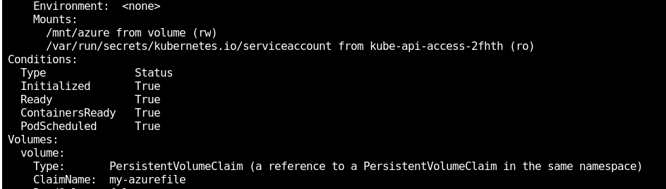

11. Delete everything created under this practice including the storage class.

Practice 4: Direct provisioning of Azure Disk storage
1. Login to Azure and connect to your AKS cluster.
2. Check if any pods run under the default namespace if so delete everything under the default namespace.

3. In this practice we will directly provision Azure Disk to a pod running inside AKS.
4. First create the disk in the node resource group. First, get the node resource group name with az aks show --resource-group myResourceGroup --name myAKSCluster --query nodeResourceGroup -o tsv .

5. Now create a disk using:
az disk create \
--resource-group MC_myResourceGroup_myAKSCluster_eastus \
--name myAKSDisk \
--size-gb 20 \
--query id --output tsv
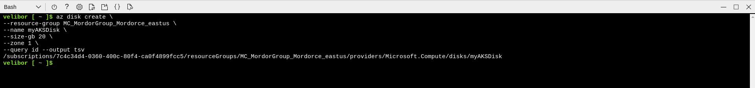

6. Make a note of the disk resource ID shown at the end of the script output. This value is needed when you create the Kubernetes volume in one of the following steps.

7. Now we can create the pod and mount the Azure Disk. Create a new file named azure-disk-pod.yaml with the following contents:
apiVersion: v1
kind: Pod
metadata:
name: mypod
spec:
containers:
- name: mypod
image: mcr.microsoft.com/oss/nginx/nginx:1.15.5-alpine
resources:
requests:
cpu: 100m
memory: 128Mi
limits:
cpu: 250m
memory: 256Mi
volumeMounts:
- name: azure
mountPath: /mnt/azure
volumes:
- name: azure
azureDisk:
kind: Managed
diskName: myAKSDisk
diskURI: <!!!!!!!!!!!!! Put the Disk resource id noted before!!!>

8. Run kubectl apply -f azure-disk-pod.yaml.
9. You now have a running pod with an Azure Disk mounted at /mnt/azure.
10. You can use kubectl describe pod mypod to verify the share is mounted successfully. Search for the Volumes section of the output.
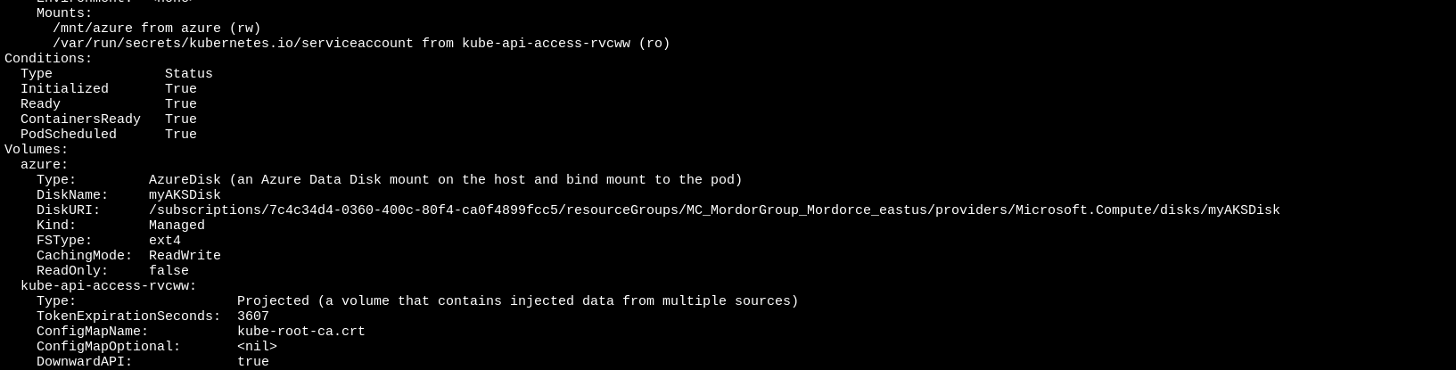

11. Now exec to the pod and try to access the mounted volume. Run the following command kubectl exec -it mypod -- bash

12. Go to /mnt/azure and try create a blank file test.txt file.

13. Delete everything created by this practice.

Practice 5: Provisioning Azure Disk storage using Storage Classes
1. Login to Azure and connect to your AKS cluster.
2. Check if any pods run under the default namespace if so delete everything under the default namespace.

3. Now we will provision Azure disk and attach it to a running pod but this time using dynamic provisioning with storage classes. List the available storage classes, run kubectl get sc.
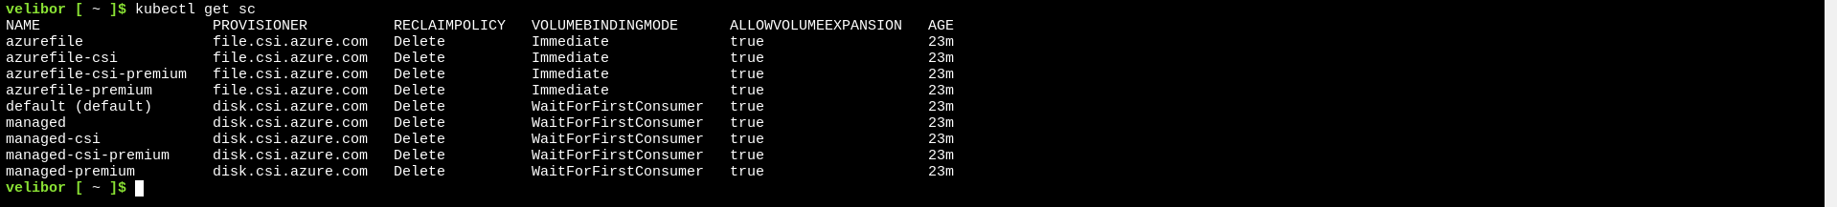

4. Examine the output. Each AKS cluster includes four pre-created storage classes, two of them configured to work with Azure disks, default and managed-premium. We will use the managed-premium in our PVC definition since it uses premium type of disks.

5. Now we will create the PVC that will consume the storage class defined previously. Create a file named azure-premium.yaml and copy in the following YAML:
apiVersion: v1
kind: PersistentVolumeClaim
metadata:
name: azure-managed-disk
spec:
accessModes:
- ReadWriteOnce
storageClassName: managed-premium
resources:
requests:
storage: 5Gi

6. Create the persistent volume claim with the kubectl apply -f azure-premium.yaml.

7. Check the status of your PVC.

8. Now we will create the pod that consumes the PVC. Create a file named azure-pvc-disk.yaml, and copy in the following YAML. Make sure that the claimName matches the PVC created in the last step:
kind: Pod
apiVersion: v1
metadata:
name: mypod
spec:
containers:
- name: mypod
image: mcr.microsoft.com/oss/nginx/nginx:1.15.5-alpine
resources:
requests:
cpu: 100m
memory: 128Mi
limits:
cpu: 250m
memory: 256Mi
volumeMounts:
- mountPath: "/mnt/azure"
name: volume
volumes:
- name: volume
persistentVolumeClaim:
claimName: azure-managed-disk

9. Create the pod with kubectl apply -f azure-pvc-disk.yaml .
10. Do a describe on the pod and check the volumes mounted.
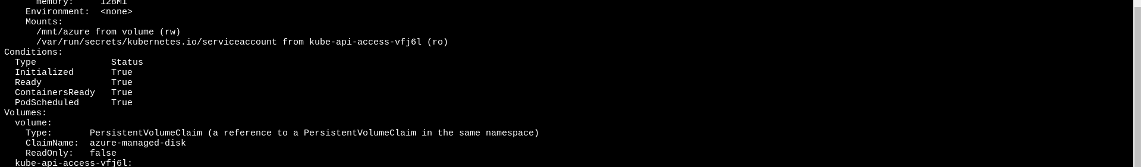

11. Delete everything created under this practice including the storage class.

*Why by default we cannot schedule pods to run on the master node?
When we setup a cluster a taint label is set on the master node that prevents any pods being scheduled on it. I guess this is because the job of the master node is managing the cluster and not adding additional tasks to it will ensure the system to run more efficiently.

